C Language
________________________________________________________________________

Q. what is c language?
_______________________________________________________________________
C is high level programming language

Q. what is programming language?
_________________________________________________________________________________
Programming means logical thought process of or logical thinking person
called as programming

Q. what is coding?
___________________________________________________________________________
If we convert your logical thinking in to computer instruction called as code.

How to create application by using c language
______________________________________________________________________________
If we want to create application by using c language we have some important steps.

1. Installed Turboc++ as editor
_________________________________________________________________
Q. what is turboc++?
__________________________________________________________________________
turboc++ is editor which provide environment to us to create and execute c program
if we want to download the turboc++ you can visit the following link
https://developerinsider.co/download-turbo-c-for-windows-7-8-8-1-and-windows-10-32-64-bit-full-screen/

2. Create Simple Application
________________________________________________________________
if we want to create application in c language we have some important steps.
a) Add header file in code
______________________________________________________
Q. what is header file?
__________________________________________________________________
header file is collection of functions
Q. what is function?
_____________________________________________________
functions are the some statements which help us to write some logic or execute the some code.
e.g printf(),scanf() etc

if we want to work with c program we need required minimum two header files
stdio.h : stdio.h stands for standard input and output header file
conio.h: console input and output header file
if we want to add header file in code we have to use #include keyword
#include<filename.h>
Example: #include<stdio.h>
#include<conio.h>

b) Write main function and logic in it.
Q. what is main function?
__________________________________________________________________
Main function is heart of c language we cannot run any c program without main function.

Syntax: void main(){
write here your logics
}

Example: we want to print good morning message on program output screen.
if we want to print anything in c language we have printf() function and this function present in stdio.h header file.
Syntax: printf(“message”);
Example: printf(“good morning”);
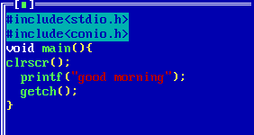
3. Save the application
4. Run the application

Data Types in C Language
_______________________________________________________________
Q. what is data type?
____________________________________________________________________
Data type means to decide what kind of information we are going to us in code called as data type.

There are three types of data type in c language?
__________________________________________________________________________
1. Built In Data Type: those data type already present in c language or provided by c language to us called as user defined data type.
There are three types of built in data type
_______________________________________________________________
a) Integer: Integer data type is used for store the values without decimal point
Example: 100,200 etc
There are four types of integer data type
_________________________________________________________________
i) Integer
How to use in program: int
Memory required: 2byte
Q. why 2 byte required?
________________________________________________
It is not fix it is dependent on compiler suppose we have some 16 bit,some 32 etc
Example:
Suppose TCC compiler required 2 byte of memory for integer
GCC compiler required 4 byte of memory for integer
JIT compiler required 4 byte of memory for integer.

Q. Can we see the memory size of data type?
________________________________________________________________________
yes we can see the memory size of data type and for that we have sizeof() operator.
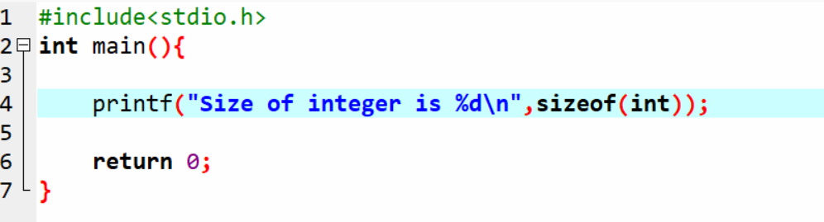

Range: range means value storage capacity of data type.
-32768 to 32767

How it is calculated?
__________________________________________________________
Range is dependent on memory size of data type.
Format specifier: format specifier means how we can represent
data type in printf() and in scanf()
%d
ii) Long Integer
_______________________________________________________
How to use in program: long int
Memory size: 4 byte
Range: -2147483648 to 2147483647
Format specifier: %ld

iii) Unsigned integer: unsigned integer is used for store only positive values.
How to use code: unsigned int
Memory required: 2 byte
Range: 0 to 65535
Format specifier : %u
iv) Short integer:
How to use in program: short int
Memory required: 2 byte
Range: -32768 to 32767
Format Specifier: %i or %d

b) Float: float data type is used for store the floating values.
There are three types of float data type
____________________________________________________________________________
I) float :
How to use in program: float
Memory required: 4 byte
Range: 38 38
-3.14 x 10 to 3.14 x 10
Format Specifier: %f
II) double:
How to use in program: double
Memory Required: 8 byte
Range: 308 308
-1.7 x 10 to 1.7 x 10
Format Specifier: %lf
III) long double
How to use in program: long double
Memory required: 10 byte
Range: 4932 4932
-1.7 x 10 to 1.7 x 10
Format Specifier: %Lf

c) Character: Character Data Type is used for store the alpha numeric values.

There are two types of character data type
i) sign char
How to use in program: char
Memory required: 1 byte
Range: -128 to 127
format specifier:%c
ii) unsigned char
How to use in program: unsigned char
Memory required: 1 byte
Range: 0 to 255

2. Derived Data Type: those data acquire the properties from another data type called as derived data type.
a) Pointer
b) Function
c) Array
3. User Defined Data Type: those data type define by user for its own use called as user defined data type.

a) Structure
b) Union
c) Enum

Operators in C Language: operator is the some symbols which is used for perform some operations.

There are seven types of operator in c language
1. Arithmetic operator: it is used for perform arithmetic operations.
Operator | Meaning
+ | Addition
- | Subtraction
* | Multiplication
/ | Division
% | Reminder or Mod
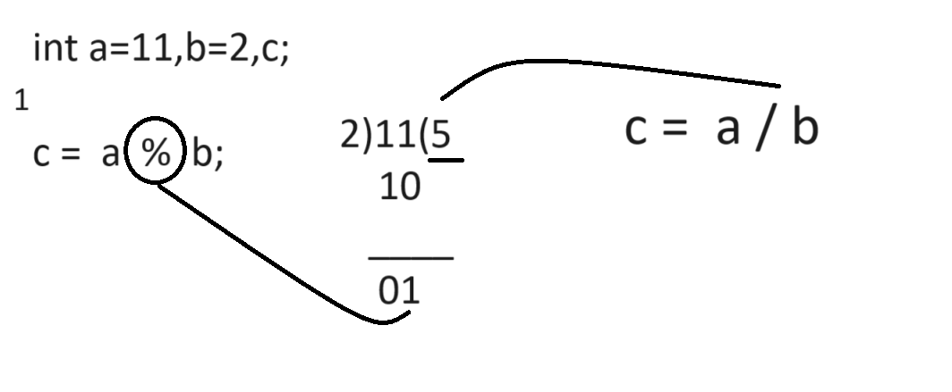

Q. what will be output of given code?
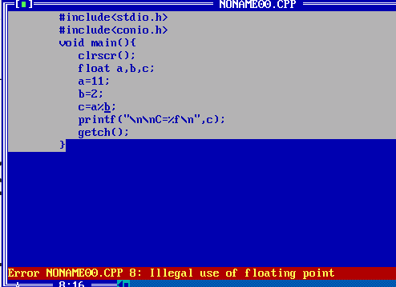
Note: Above code generate compile time error to us illegal use of floating point.
Because we use the reminder operator or mod operator with floats values but in c language there is rule we cannot use reminder or mod operator with floating data type.

How I can calculate reminder of floating values in c language
_____________________________________________________________________
There are two ways to calculate reminder of floating values
A) Using fmod() from math.h header file.
______________________________________________________________
fmod() is function from math.h header file which is used for calculate reminder of floating values.
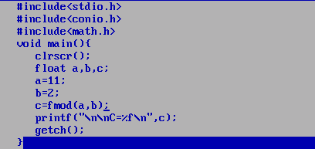
Output: C = 1.00000

B) Using type casting technique
Q. what is type casting?
________________________________________________________________________
Type casting means convert one type of data in to another type for single line of code called as type casting.

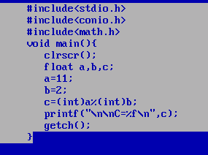

2. Assignment operator : it is used for assign right hand side value to left hand side variable.
Operator | Meaning
= | Assign

3. Relational operator: Relational operator is used for perform comparison if comparison gets success return 1 otherwise return 0. In The case of c language 1 means true and 0 means false.
Operator | Meaning
> | Greater than
< | Less Than
>= | Greater than equal
<= | Less Than Equal
== | Equal
!= | Not Equal
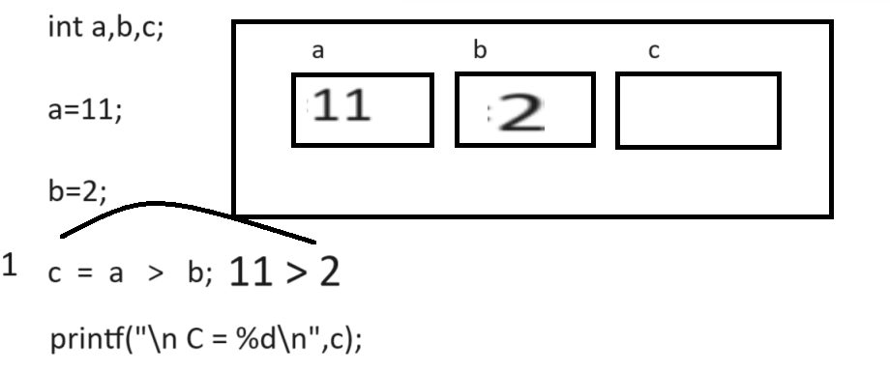
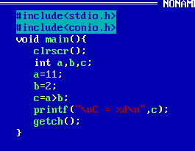

4. Logical Operator: Logical operator is used for combine more than one conditions and checks it or mark it as single condition.

Operator | Meaning
&& | Logical AND if we think about AND operator if all conditions are true then condition is true otherwise condition is false.
|| | Logical OR if we think about Logical OR if any one condition is true then condition is true if all conditions are false then condition false.
! | Logical NOT if true condition then false and if false then true.

Note: Every logical Operator work as Logical Gate Internally and condition consider as input to logical Gate.
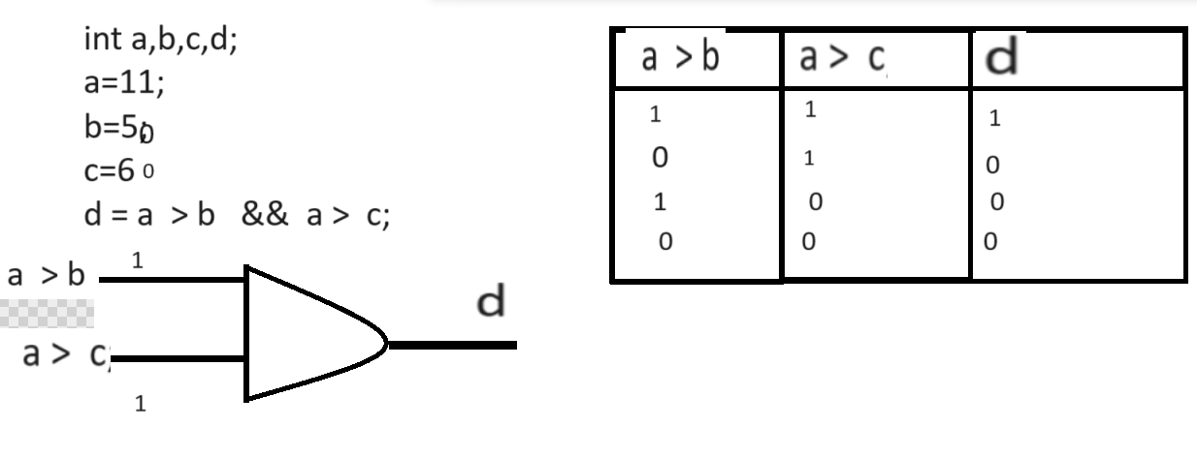

5. Increment or decrement: it is used for increase value by 1 or decrease value by 1
It is short cut of +1 and -1
There are two types of operator
Operator | Meaning
++ | Increase by 1
-- | Decrease by 1

There are two types of increment and decrement operator
_______________________________________________________________________________
Post Increment and Post Decrement: In the case of post operation first we initialize value at left hand side and after that we perform operation on it.
Syntax: variablename op;
int a=10;
int b=a++;

Pre Increment and Pre Decrement: In the case of pre increment operation or pre decrement operation first we perform operation and after that shift value at left hand side.

Syntax: op variablename;
Example: int a=10;
++a;// pre increment

Example of post increment
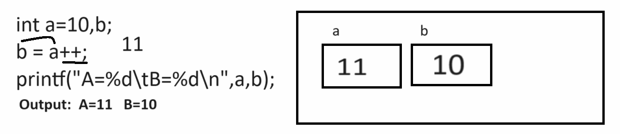
Output
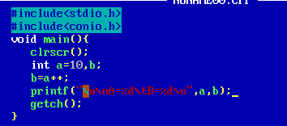
Output:
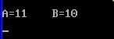
Example of pre increment
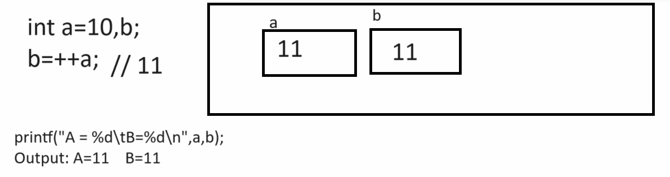
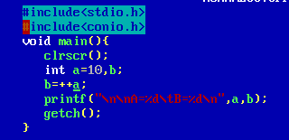
Output:
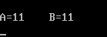
6. Conditional operator: conditional operator is used for check the conditions.
Operator | Meaning
? | Ternary operator
: | Colon operator

If we want to work with conditional operator we have following standard syntax.

Syntax: exp1? exp2: exp3;
exp1 is always condition and exp2 and exp3 are the options if exp1 is true then exp2 get executed if exp1 is false then exp3 get executed.

Example:
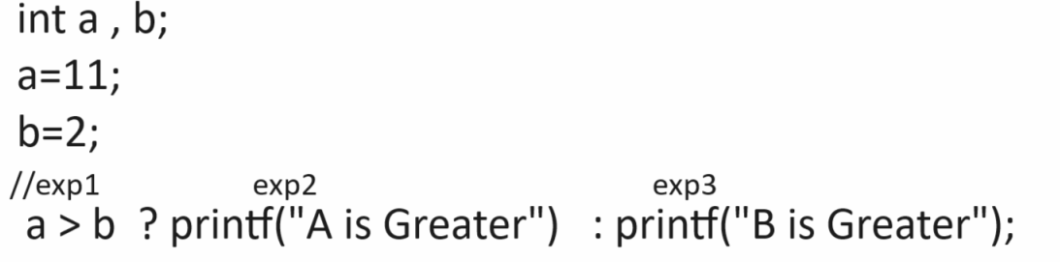

Constant in C Language
___________________________________________________________________________
Q. what is constant?
________________________________________________________________
Constant means value never change in program called as constant

Q. Why use constant or what is benefit of constant?
_______________________________________________________________________
Reusability is major goal of constant

Types of constant in c language
a) Numeric constant
i) Integer constant: that constant store only without decimal point number called as integer constant
Example: 100,200 ,
ii) float constant: float constant is used for store floating values like as
5.4,2.4,etc
iii) octal constant: if we have any value between 0 to 7 preceding 0 called as octal
Example: 072
iv) hexa decimal constant: if we have any value between 0 to 15 and start with 0x
called as hexa decimal
Example: 0x72
b) Character Constant:
i) single character constant: if we use any value between single quote called as single character constant.
Example: ‘a’, ‘5’, ‘z’
ii) string character constant: when we want to store more than one character as constant then we can use string and we can mention the string constant by using “”
Example: “abc”, “mno”,”pqr” etc

7. Bitwise operator.

Example: WAP to declare two variables and calculate its addition.
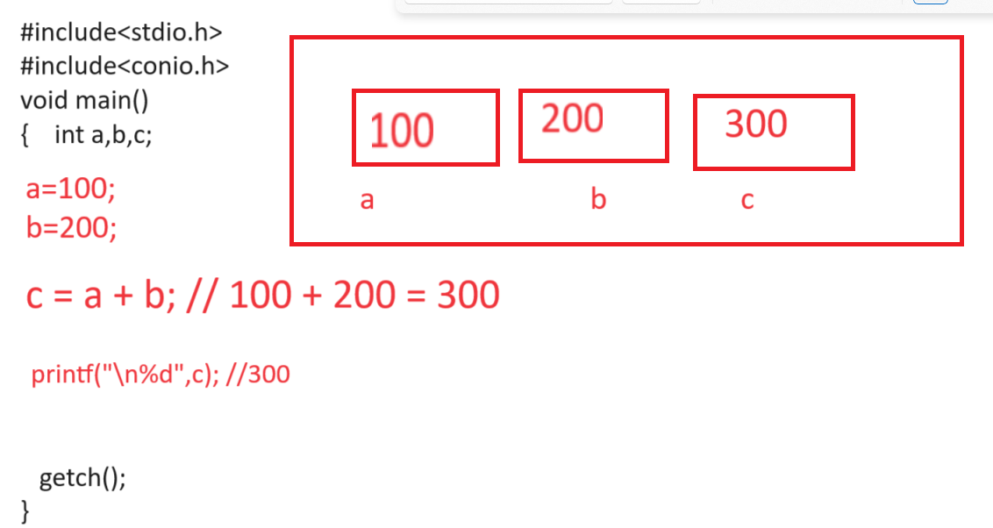
If we think about above code we calculate addition two fix values
But we want to accept input from keyboard at program run time and after that calculate its addition.

How to accept input after program run in c language
__________________________________________________________________________
If we want to accept the input from keyboard using c language we have scanf() function and it is member of stdio.h header file.

Syntax of scanf()
______________________________________________________________________________
scanf(“format specifier”,&variablename);

Example: we want to accept two input values.
int a,b,c;
scanf(“%d %d”,&a,&b);

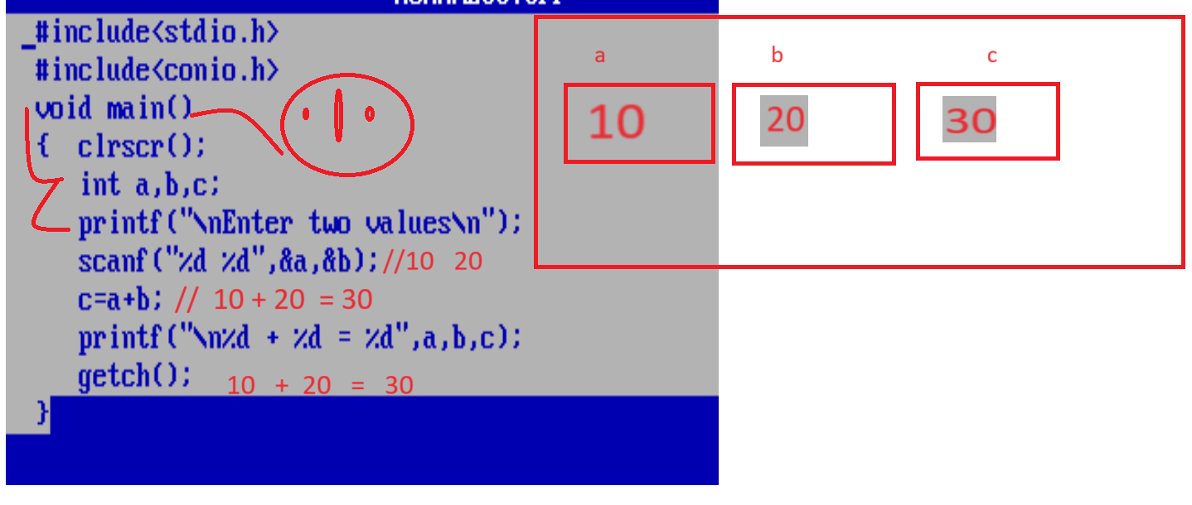

Example:
_________________________________________________________________________
WAP to input the radius of circle and calculate its area.

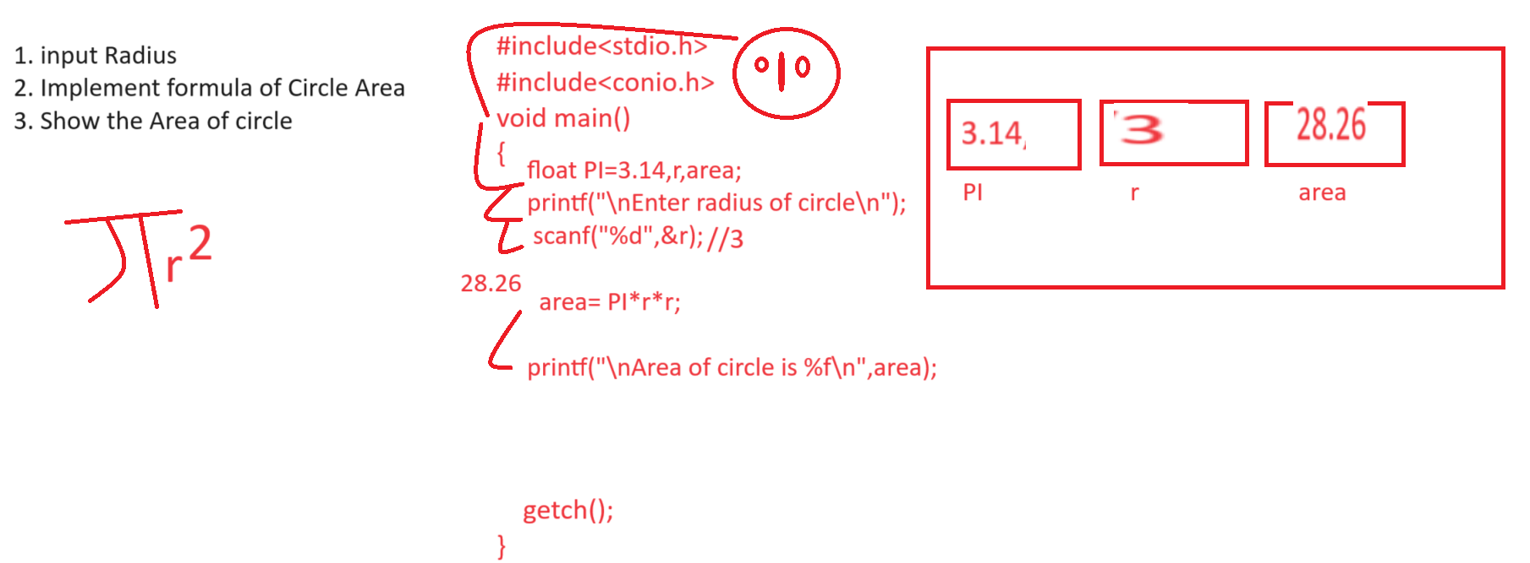
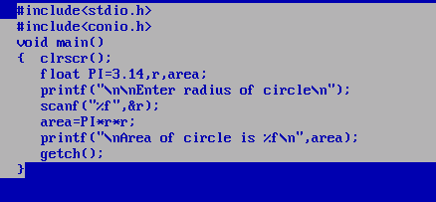

Example: WAP to input qty and rate of product from keyboard and calculate its total
bill with 18% GST

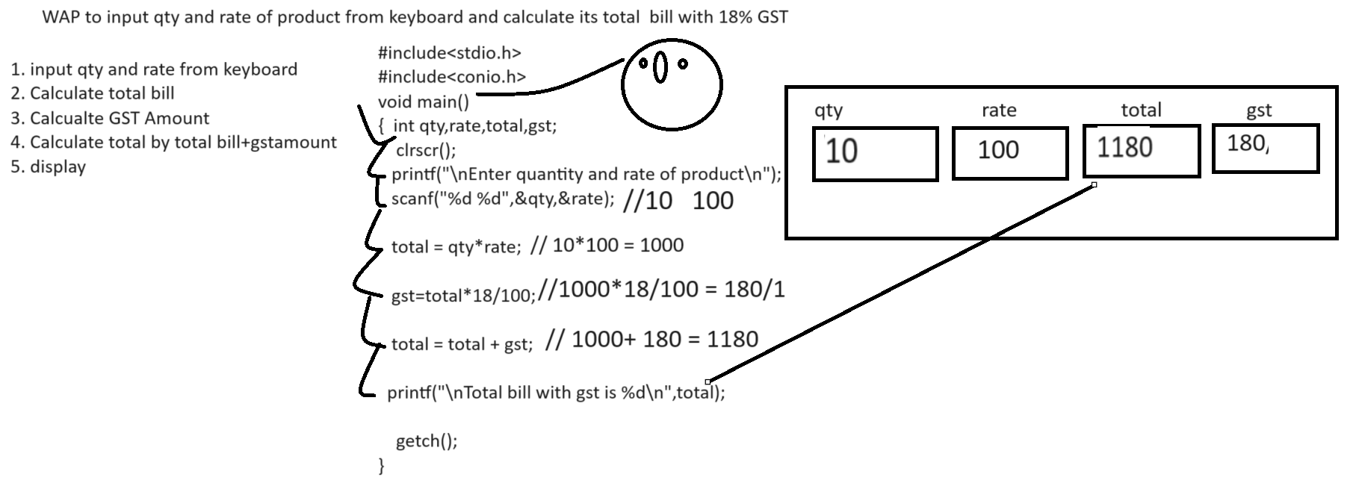

Example: WAP to input the selling price of item and cost price of item and check seller made profit or loss
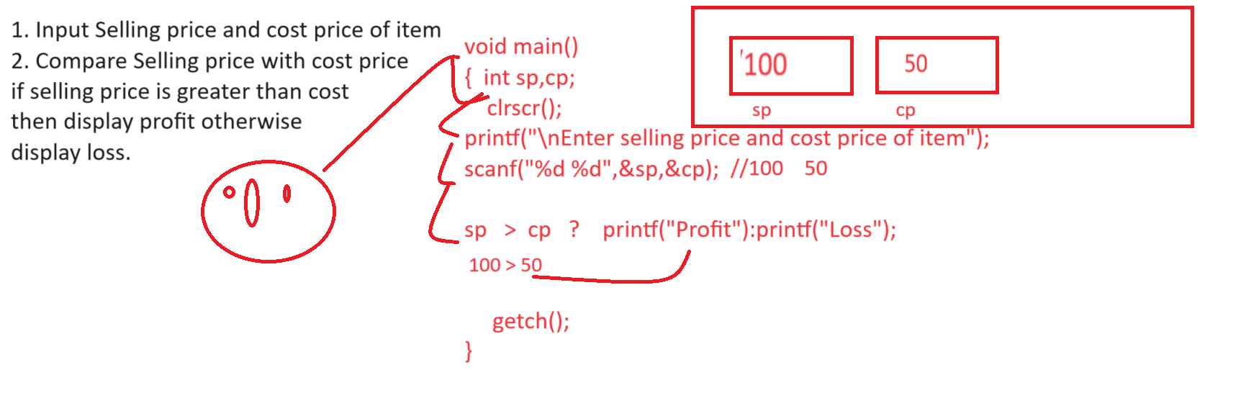

Example:
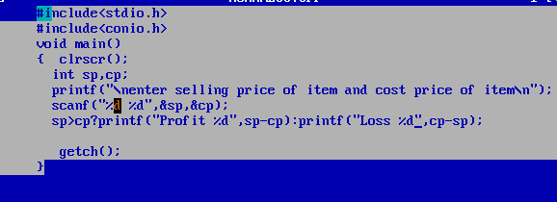

Example: WAP to input four digit number and extract last digit and display it.
Input: 1234
Output: 4
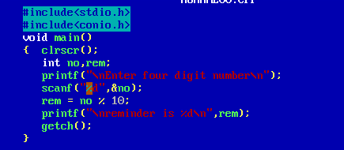

Example: WAP to input the four digit number and remove the last from number
Input: 1234
Output: 123
Note: if you want to remove the last digit of number then divide number by 10 and take its result and store in number.
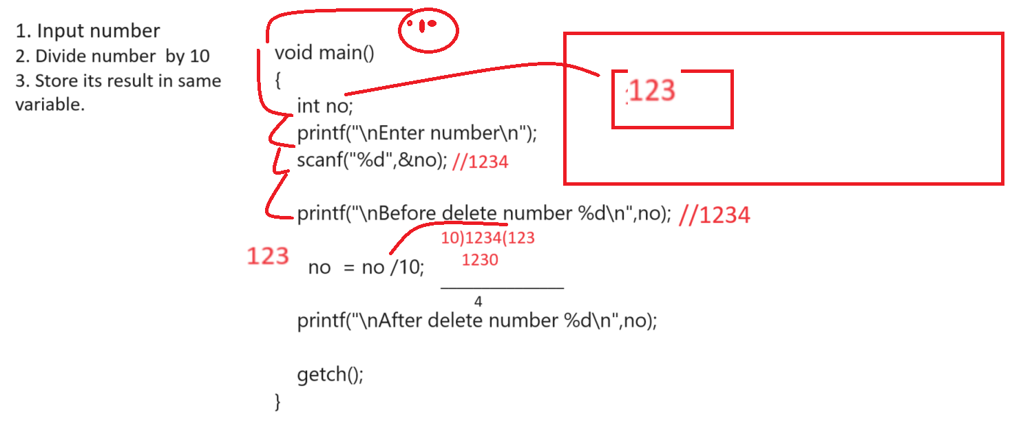
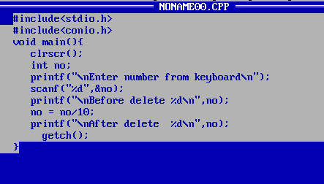

Example: WAP to input three digit numbers and calculate its digit sum
Input: 123
Output: 1+2+3 = 6
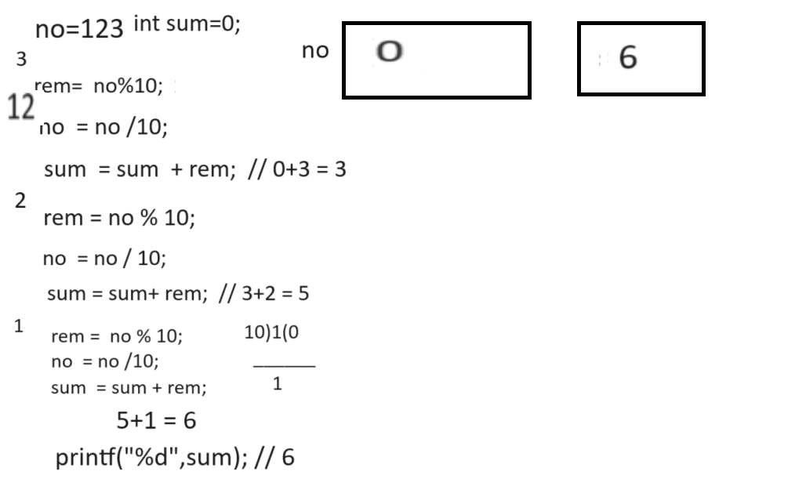
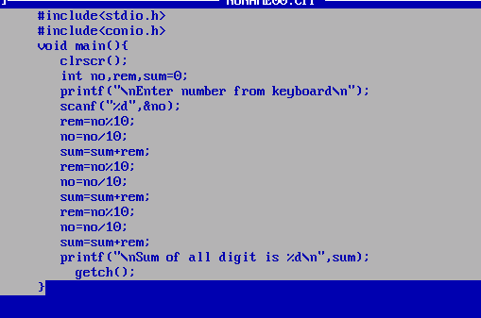
or
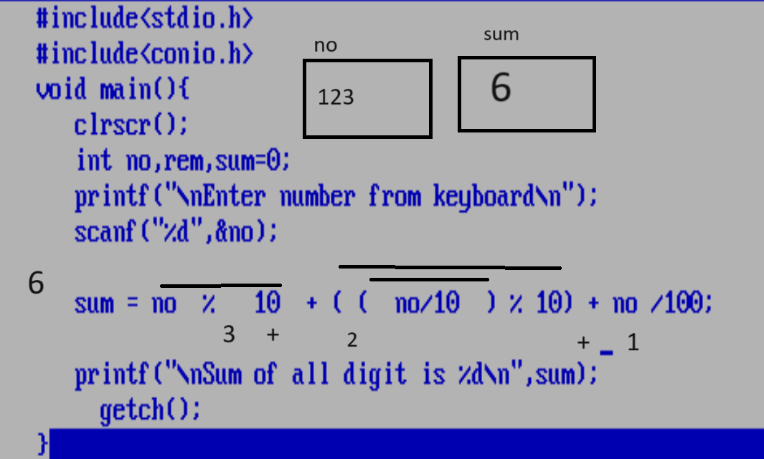
Example: WAP to input three digit numbers and reverse it
Input: 123
Output: 321
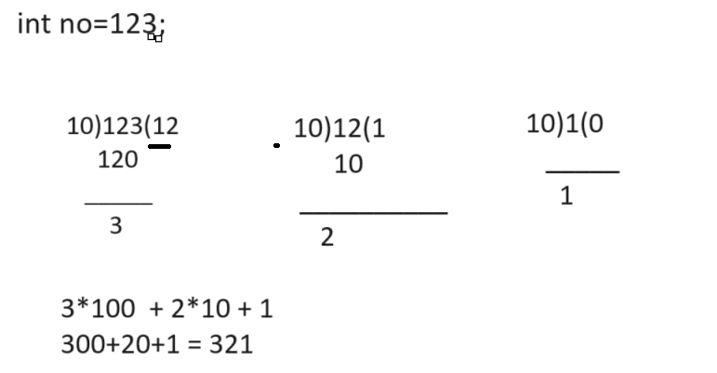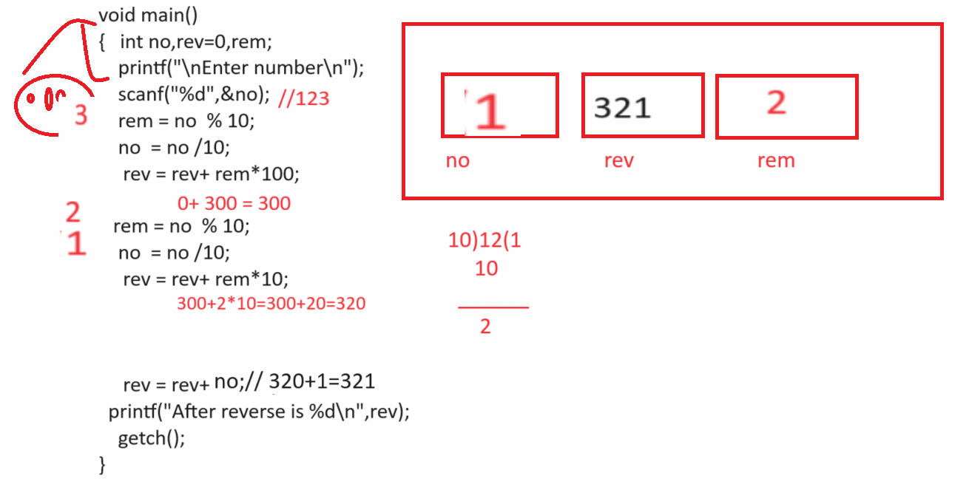

or
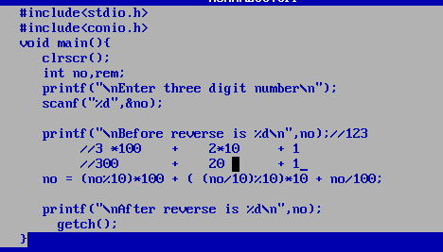

Example: WAP to input four digit and swap its fast and last digit only
Input: 1234
Output: 4231

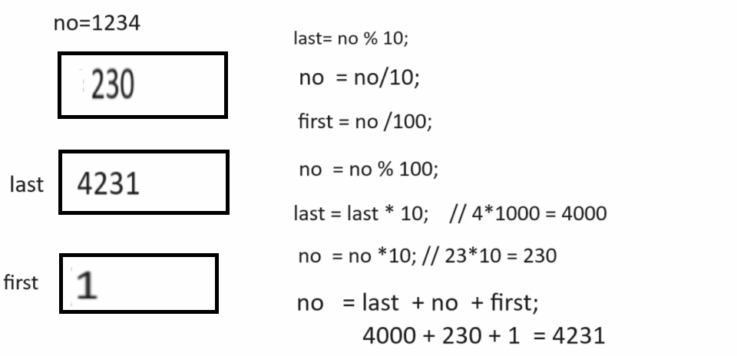

Bitwise operator
___________________________________________________________________________
Q. what is bitwise operator?
______________________________________________________________________
Bitwise operator is used for perform the operation on bits.
If we want to work with bits operator we need to know the some important things

1. Number system
2. Conversion between decimal number to binary and binary to decimal
3. Bitwise AND, OR, XOR, one’s complement and 2’s complement operators

Q. What is Number System?
__________________________________________________________________
Number system means decide how number represent or how user values represent in computer called as Number System.

Types of Number System
___________________________________________________________________________________
1. Decimal Number: decimal number system means value between 0 to 9 and the base of decimal number system is 10
Base means calculate the total number of digits in number system as well as base help identify the number and its category

Example: (123)
10 --- Base
2. Binary Number: Binary Number system means number system contain two values i.e. 0 and 1 so the base of binary number system is 2

Example: (0101010)
2 – base

3. Octal Number: Octal number system means number contain 0 to 7 values so the base octal is 8.

Example: (72)
8
4. Hexa Decimal Number System: Hexa decimal number system number contains values between 0 to 15 so the base of hexa decimal number system is 16 and from 10 A to F means 10 consider as A, 11 as B , 12 as C and 13 D and 14 E and 15 consider F in hexa

Example: (123AF) the meaning is (1231015)
16 16

How to convert decimal number to binary number
__________________________________________________________________________________
If we want to convert any decimal number in to binary then we need to divide a decimal number by 2 and calculate its reminder and take all reminder from bottom to top.

Example: we want to find the binary of decimal 5
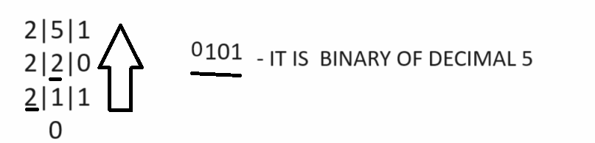

Example: find the binary number of decimal 13

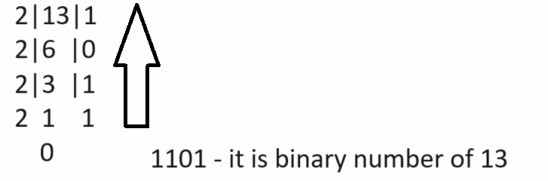

How to convert binary number to decimal number
_______________________________________________________________________________
if we want to convert binary number to decimal number we need to multiply number by 2 and provide index to every binary digit from right to left and first index should be 0

Example: find the decimal number of 1101
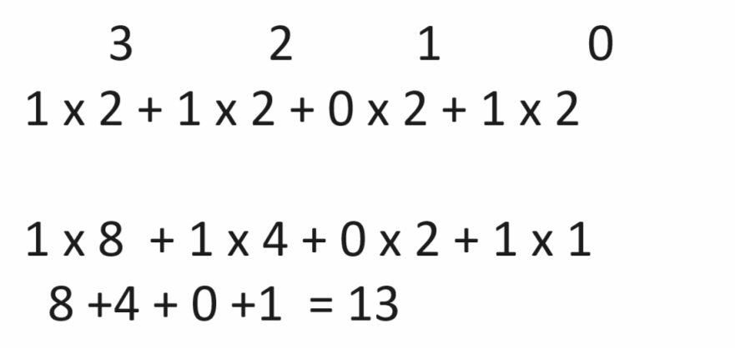

Example: Find the decimal number 1111
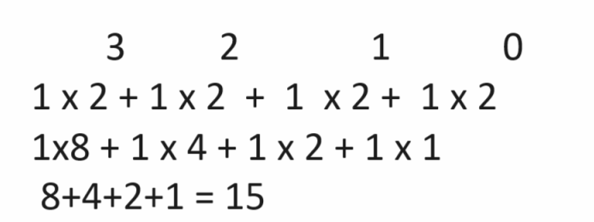

Bitwise AND Operation: If we think about bitwise AND operation then if both inputs are 1 then output is 1 otherwise 0
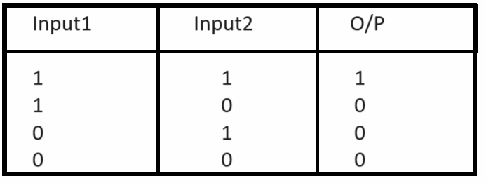
Bitwise OR operation: if we think about bitwise OR operation if anyone input is 1 then output is 1 otherwise output is 0.
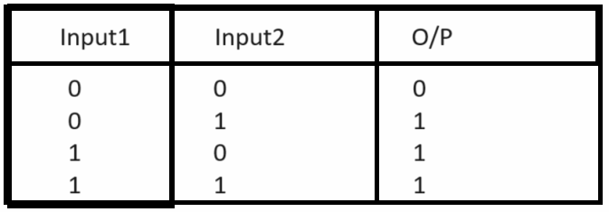

Bitwise XOR Operation
_____________________________________________________________________________
If we think about XOR operation different input consider as 1 and same inputs consider 0
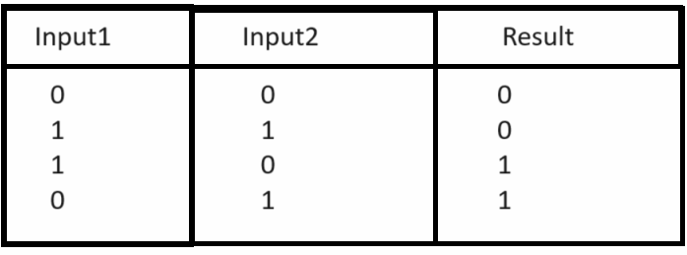
One’s Complement: If we think about binary operation one’s complement is negation operation or it is negative operation.
Means in one’s complement operation we convert 0 to 1 or 1 to 0

Example: Find the one’s complement of 0101
Original Binary: 0101
One’s Complement: 1010

Two’s Complement: two complement can apply on binary after one’s complement and add +1 at right hand side of binary number after one’s complement.

Example: Find the two’s complement of 1011
First Need to perform one’s complement: 0100
Perform two’s complement on 1’s complement value :
0100
+1
_________
0101 – It is 2’s complement of 1011

Bitwise operator in C Language
Operator | Meaning
| | Bitwise OR
& | Bitwise AND
<< | Left shift operator
>> | Right shift operator
~ | One’s Complement
^ | XOR Operator

Bitwise OR operator: bitwise OR operator is used for perform or operation on decimal number and generate its result.
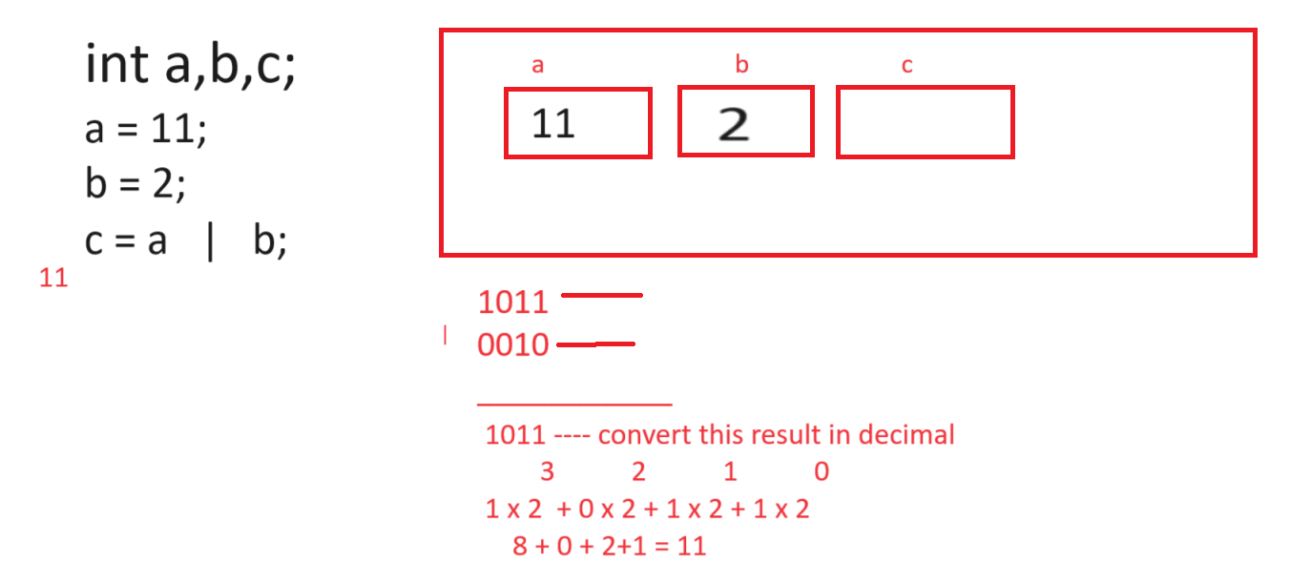
Q. what will be output of given code?
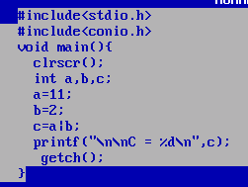
Output: C = 11.

Q. what will be output of given code?
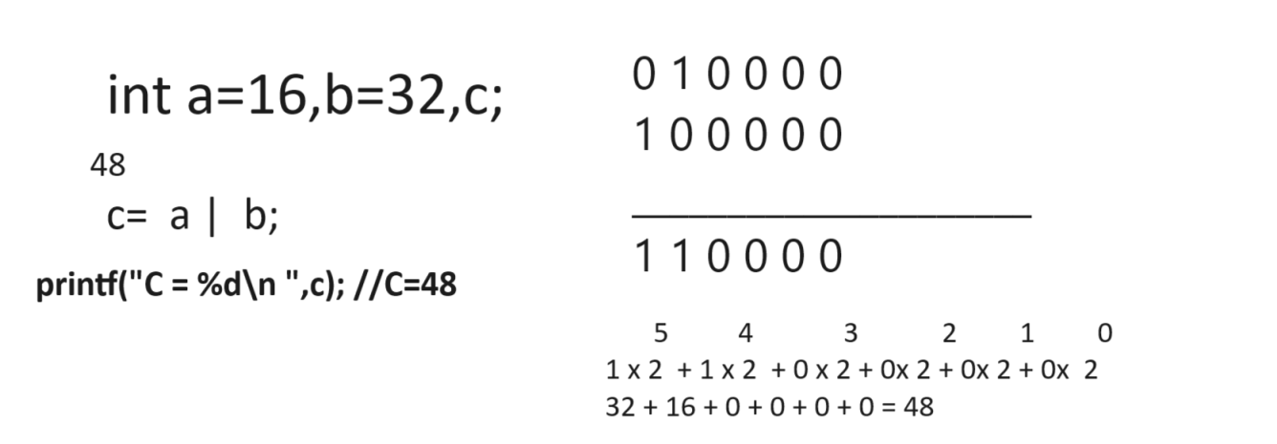

Bitwise & (AND) operator
_________________________________________________________________________________
Bitwise & operator is used for perform bitwise & operation on bits.
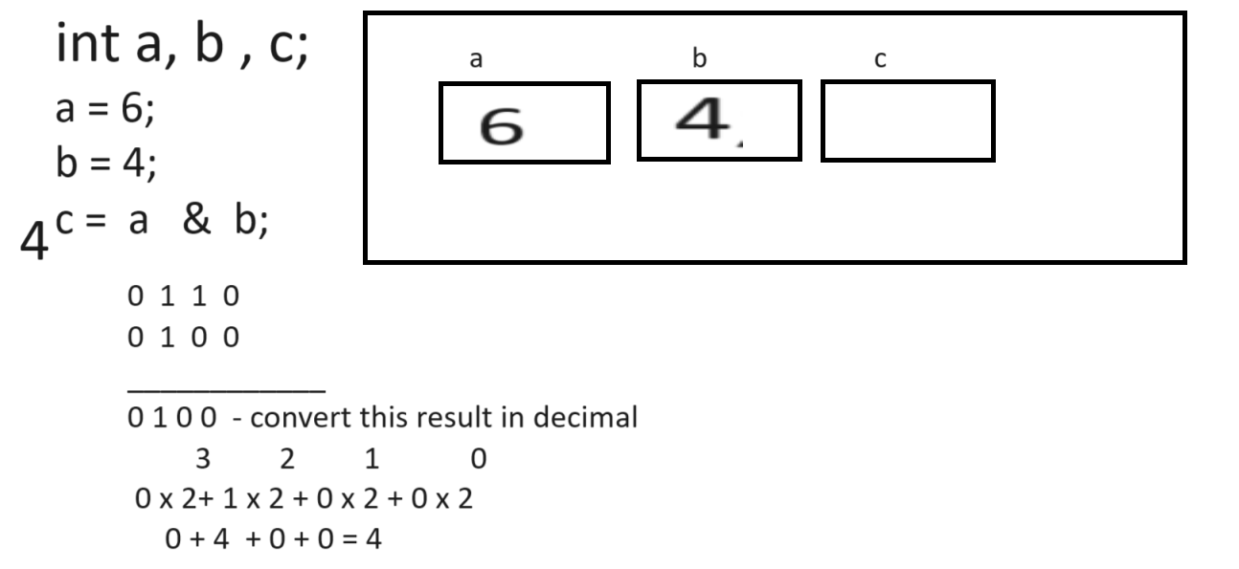

Example:
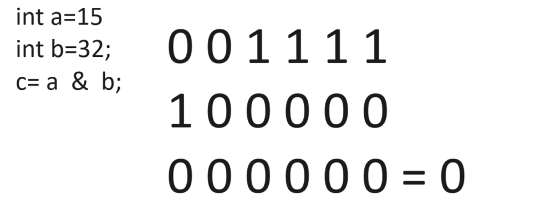

<< (Left shift operator) : this operator is used for shift the bit from right hand side to left hand side and 0’s at right hand side.

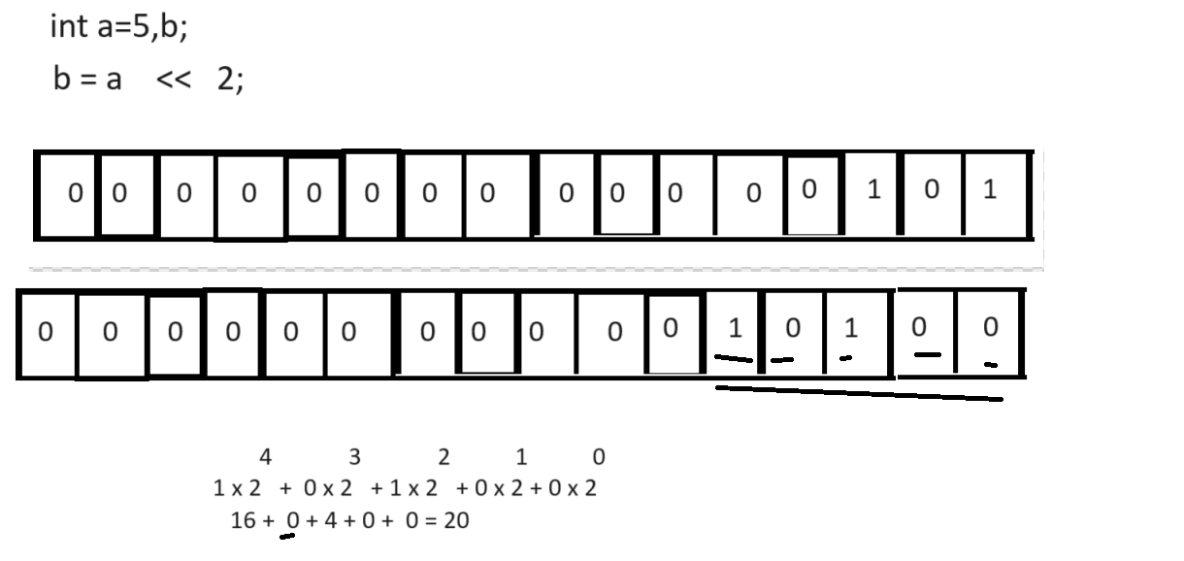
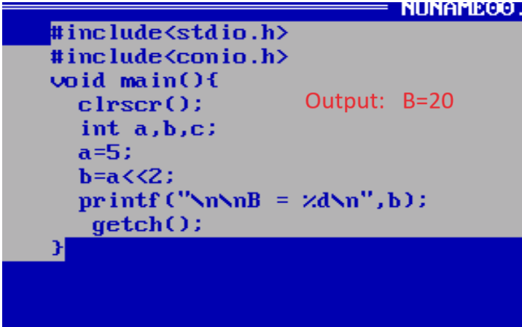

Q. what will be output of given code?
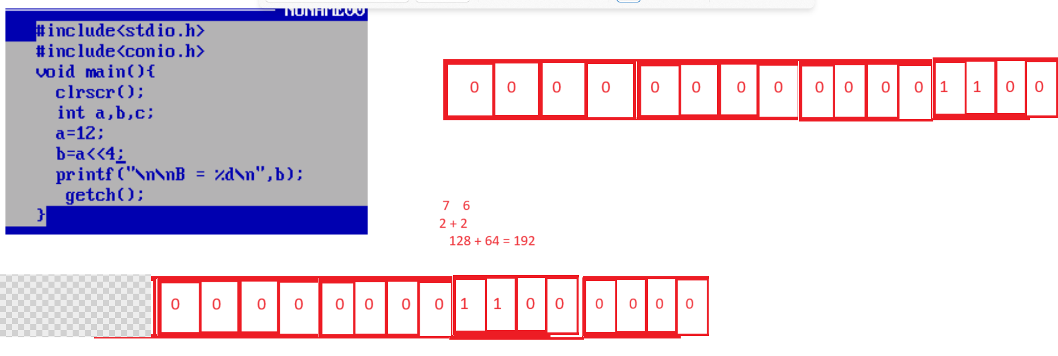
Output: B = 192

>> (right shift operator): this operator helps us to shift bit at right hand side and 0’s at left hand side.
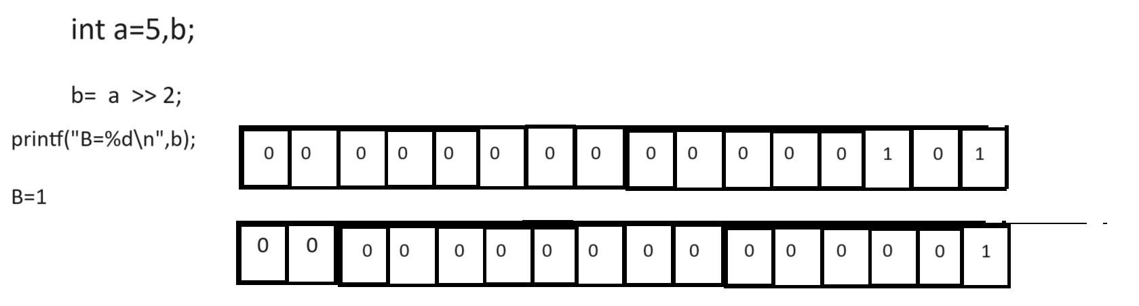
Q. what will be output of given code?
___________________________________________________________________________
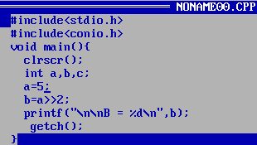
Output: B = 1

XOR Operator (^): XOR operator can perform operation when both input same then result is 0 if inputs are different then return 1
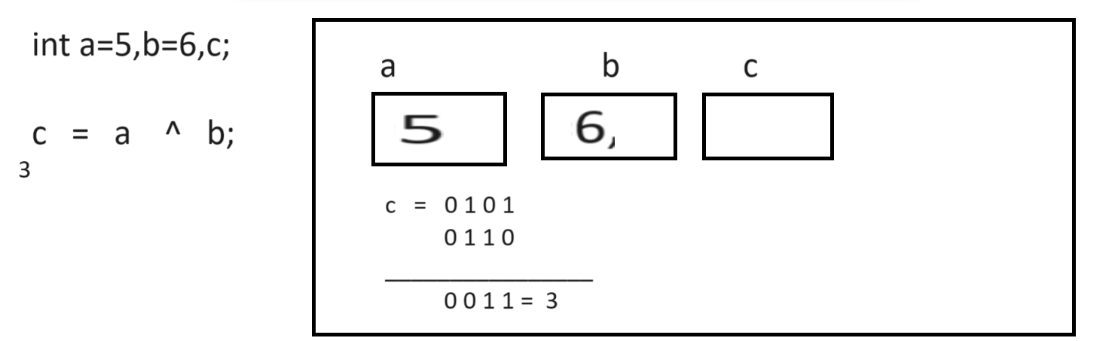

One’s complement operator
_____________________________________________________________________
~ (one’s complement operator): this is used for perform negation operation i.e complement operator.
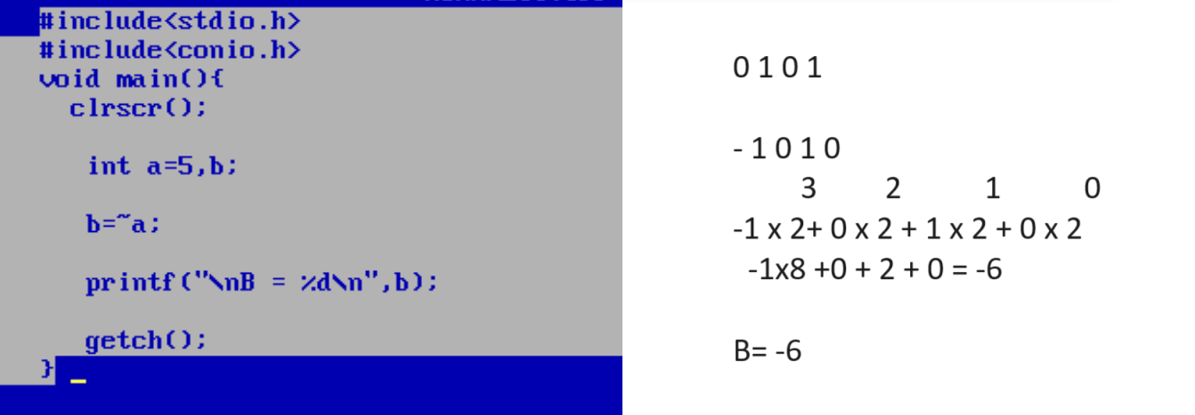

Operator priority or Precedence of operator in C Language
_____________________________________________________________________________________
Operator priority means decide the execution priority of operator in expression means when we have multiple operator present in expression then decide which operator execute when called as operator priority.

Following chart demonstrate the priority of operator
__________________________________________________________________________
Precedence | Operator | Associativity
1 | (),[],++,--(pre), . , -> | Left to right
2 | - (unary),!,sizeof, &(address) | Right to left
3 | * / % | Multiplicative , division and reminder
4 | + - | Addictive operator
5 | <<, >> | Left to right
6. | < <= > >= | Left to right
7 | == != | Left to right
8 | & | Left to right
9 | ^ | Left to right
10 | | | Left to right
11. | && | Left to right
12 | || | Left to right
13. | ? : | Right to left
14 | ++ , -- (post) | Left to right
15 | += , - = , *= , /= , %= etc | Right to left
16 | , | Comma operator

Output
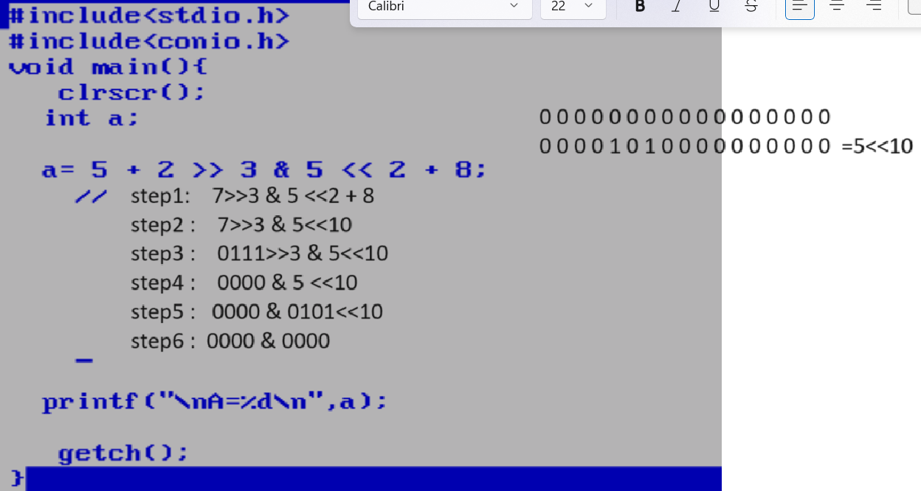
Q. what will be output of given code?
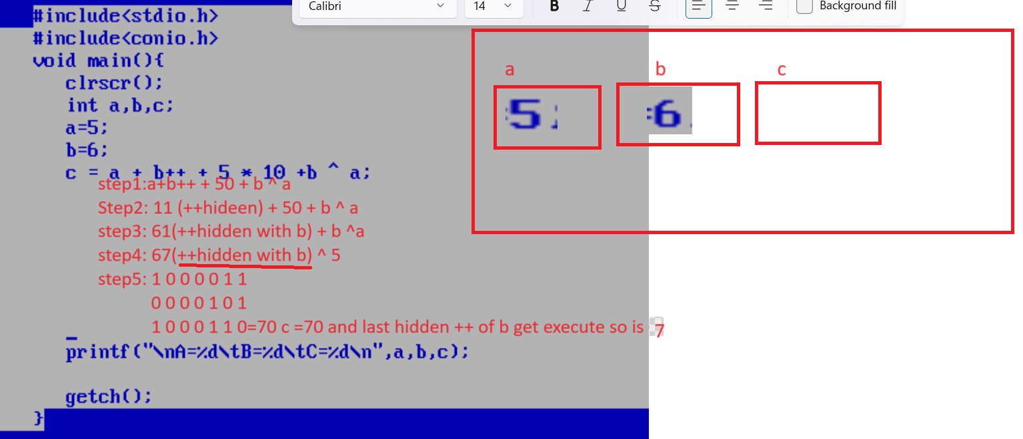
Q. what will be output of given code?
